

**LAB 3**

Submitted by:

Name: Haseeb Ullah

ID No: F20232661009

Section: V12

OOPs

Submitted to:

M. OWAIS KHAN

**CLASSES & OBJECT**

Date : 03/25/2023

C-II Block C 2 Phase 1 Johar Town, Lahore, Punjab 54770.

**Task 1**

Write a program by using a class that takes name, age and city of a person as class attributes. An input Details member functions to input the data, getAge function to return age and Display function to display name , age and city.Input the data for two persons and display the record of the person who is elder in age.

**Source code:**

|  |
| --- |
| **#include <iostream>**  **using namespace std;**  **class Student**  **{**  **string name,city;**  **int age;**  **public:**  **void setdata(string nam, int a, string address)**  **{**  **name = nam;**  **age = a;**  **city = address;**  **}**  **int getAge()**  **{**  **return age;**  **}**  **void display()**  **{**  **cout << name << " , " << age << " , " << city << endl;**  **}**  **};**  **int main()**  **{**  **Student std[2];**  **string name,address;**  **int age;**  **for(int i = 0; i < 2; i++)**  **{**  **cout << "Enter the name: " << i + 1 << " :";**  **cin >> name;**  **cout << "Enter Age: ";**  **cin >> age;**  **cout << "Enter the address: ";**  **cin >> address;**    **std[i].setdata(name,age,address);**    **}**    **cout << endl;**  **cout << endl;**  **cout << endl;**    **if(std[0].getAge() > std[1].getAge())**  **{**  **std[0].display();**  **}**  **else**  **{**  **std[1].display();**  **}**    **return 0;**  **}** |

**Output:**

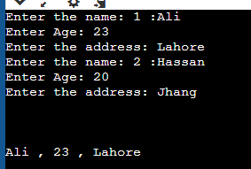

**Task 2**

Create a class called "Rectangle" to represent rectangles. Each rectangle should have a length and a width. Implement getter and setter functions for both the length and width. Add a member function to calculate the area of the rectangle.

**Source code:**

|  |
| --- |
| **#include <iostream>**  **using namespace std;**  **class Rectangle**  **{**  **double length,width;**  **public:**  **void setter(double len, double wid)**  **{**  **length = len;**  **width = wid;**  **}**  **double getter()**  **{**  **return length * width;**  **}**  **};**  **int main ()**  **{**  **Rectangle rectangle;**      **rectangle.setter( 3, 6 );**    **cout << rectangle.getter();**      **return 0;**  **}** |

**Output:**

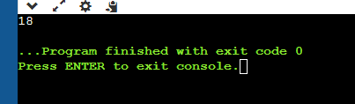

**Task 3**

Create a class called "Student" to represent a student. Each student should have a name, an ID, address, and a GPA. Implement getter and setter functions for each data member. Add a member function to print out the student's information.

**Source code:**

|  |
| --- |
| **// Create a class called "Student" to represent a student.**  **// Each student should have a name, an ID, address, and a GPA.**  **// Implement getter and setter functions for each data member.**  **// Add a member function to print out the student's information.**  **#include <iostream>**  **using namespace std;**  **class Student**  **{**  **string name,city;**  **int id;**  **float gpa;**  **public:**  **void setdata(string nam, int ids, float gpa, string address);**  **void display();**  **};**  **void Student::setdata(string nam, int ids, float cgpa, string address)**  **{**  **name = nam;**  **id = ids;**  **gpa = cgpa;**  **city = address;**  **}**  **void Student :: display()**  **{**  **cout << "Name: " << name<<endl;**  **cout << "ID: " << id <<endl;**  **cout << "GPA: " << gpa <<endl;**  **cout << "Address: " << city <<endl;**  **}**  **int main()**  **{**  **Student student;**  **string name,address;**  **int id;**  **float gpa;**  **cout << "Enter the name: ";**  **cin >> name;**  **cout << "Enter Age: ";**  **cin >> id;**  **cout << "Enter GPA:";**  **cin >> gpa;**  **cin.ignore();**  **cout << "Enter the address: ";**  **cin >> address;**  **cin.ignore();**  **student.setdata(name,id,gpa,address);**  **cout << endl;**  **cout << endl;**  **cout << endl;**  **student.display();**  **return 0;**  **}** |

**Output:**

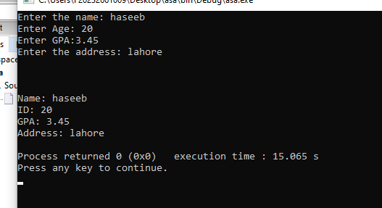

**Task 4**

Create a class called "Car" to represent a car. Each car should have a make, a model, a year, and a color. Implement getter and setter functions for each data member. Add a member function to print out the car's information.

**Source code:**

|  |
| --- |
| **//Create a class called "Car" to represent a car.**  **//Each car should have a make, a model, a year, and a**  **//color. Implement getter and setter functions for each data member.**  **//Add a member function to print**  **//out the car's information.**  **#include <iostream>**  **using namespace std;**  **class Car**  **{**  **string make,model;**  **int year;**  **string colour;**  **public:**  **void setdata(string make1, string model1,int year1,string colore1);**  **void display();**  **};**  **void Car::setdata(string make1, string model1,int year1,string colore1)**  **{**  **make = make1;**  **model = model1;**  **year = year1;**  **colour = colore1;**  **}**  **void Car :: display()**  **{**  **cout << "Make: " << make<<endl;**  **cout << "Model: " << model <<endl;**  **cout << "Year: " << year <<endl;**  **cout << "Colour: " << colour <<endl;**  **}**  **int main()**  **{**  **Car car;**  **string make,model;**  **int year;**  **string colour;**  **cout << "Make: ";**  **cin >> make;**  **cout << "Enter model: ";**  **cin >> model;**  **cout << "Enter year:";**  **cin >> year;**  **cin.ignore();**  **cout << "Enter the colour: ";**  **cin >> colour;**  **cin.ignore();**  **car.setdata(make,model,year,colour);**  **cout << endl;**  **cout << endl;**  **cout << endl;**  **car.display();**  **return 0;**  **}** |

**Output:**

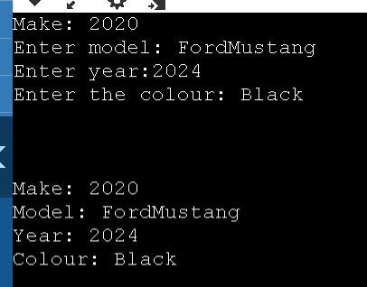

**Task 5**

Create a class called "BankAccount" to represent a bank account. Each bank account should have an account number, a balance, and an interest rate. Implement getter and setter functions for each data member. Add a member function to calculate the interest earned on the account**.**

**Source code:**

|  |
| --- |
| **#include <iostream>**  **using namespace std;**  **class BankAccount {**  **private:**  **int account_number;**  **double balance;**  **double interest_rate;**  **public:**    **void setter(int a_number, double total_bal, double intrst_rate )**  **{**  **account_number = a_number;**  **balance = total_bal;**  **interest_rate = intrst_rate;**    **}**  **double cal_interest() {**  **return balance * (interest_rate / 100.0);**  **}**  **void get_acc_details(void);**  **};**  **void BankAccount ::get_acc_details(void)**  **{**  **cout << "Account Number: " << account_number << endl;**  **cout << "Balance:" << balance << endl;**  **cout << "Interest rate: " << interest_rate << endl;**    **cout << "Interest Earned: " << cal_interest() << endl;**  **}**  **int main() {**  **BankAccount haseeb;**    **haseeb.setter(967,99999, 10.02);**    **haseeb.get_acc_details();**    **return 0;**  **}** |

**Output:**

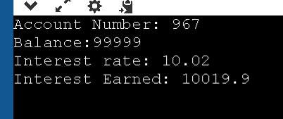

Task 6

Create a class called "Time" to represent a time of day. Each time should have an hour, a minute, and a second. Implement getter and setter functions for each data member. Add a member function to print out the time in 12-hour format.

**Source code:**

|  |
| --- |
| **//Create a class called "Time" to represent a time of day.**  **//Each time should have an hour, a minute, and a second.**  **//Implement getter and setter functions for each data member.**  **//Add a member function to print out the time in 12-hour format.**  **#include <iostream>**  **using namespace std;**  **class Time {**  **private:**  **int hour;**  **int minute;**  **int second;**  **public:**  **void setter(int h, int m, int s) {**  **hour = h;**  **minute = m;**  **second = s;**  **}**  **void display() {**    **if(hour<12)**  **{**  **cout << hour << ":"<< minute << ":" << second << " AM";**  **}**  **else**  **{**  **cout << hour << ":"<< minute << ":" << second << " PM";**  **}**    **}**  **};**  **int main() {**  **Time t;**  **t.setter(2, 33, 4);**  **t.display();**  **return 0;**  **}** |

**Output:**

